Teen Ambassadors to Jewish Cuba Itinerary

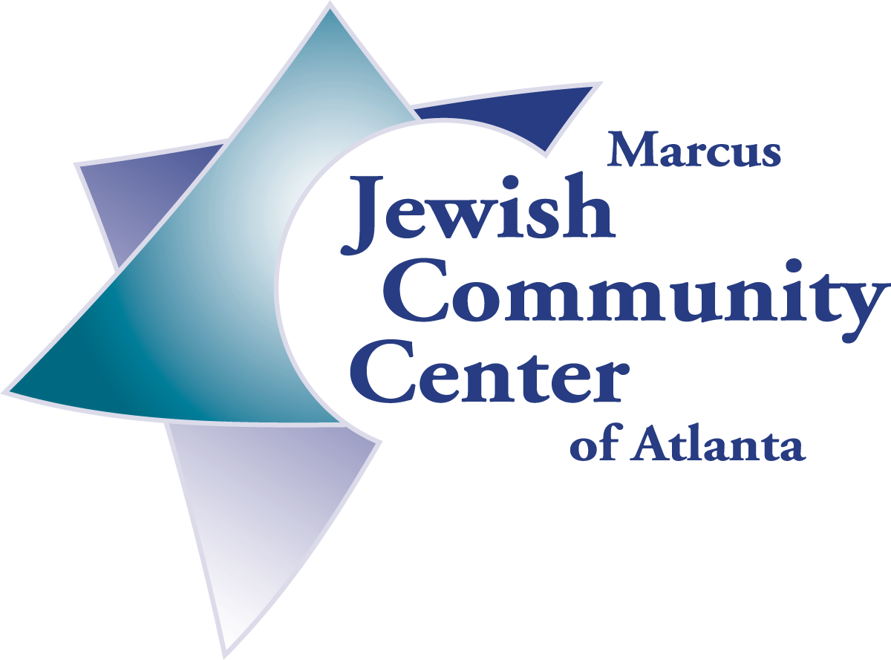

DRAFT

Monday April 14th - Arrive at Jose Marti Airport in Havana. Will be met by local representative and bus to transport group to hotel. Check in at hotel. Orientation session, going over itinerary and any last minute changes. Explanation of expectations and "housekeeping" information. Dinner at hotel. If time allows, welcome session by Jewish Community Members.

Tuesday, April 15th - Breakfast at hotel. Transportation and guide for morning walking tour of Habana Vieja. Guide will educate group on history of this important area of Havana. All sights will be seen on foot. Bus will meet us to take us to Patronato to meet with the leadership and deliver aid. We will visit the pharmacy, deliver medical donations and help with chores in this complex. This evening we will dine and have a briefing at the home of the Head of the United States Interest Section in Miramar.

Wednesday, April 16th - Breakfast at hotel. Morning Bus trip to Guanabacoa. On the way stop at Cojimar, Hemingway's fishing village. In Guanabacoa, visit the Jewish Cemeteries, visit the Holocaust Memorial. Memorial service by teens. Participate in cleanup at the cemetery. Return to Havana Vieja. Visit Adat Israel Synagogue and deliver aid. Visit Centro Sepharadi and deliver aid. Swim at leisure, walk in the Malecon, finish preparations for Seder. If Patronato asks for help, help with Seder preparations at the Patronato. Transportation for Pessach Seder and Meal at the Patronato.

Thursday, April 17th - Breakfast at hotel. Board bus for day trip outside Havana. We will head west into cigar country to the western province of Pinar del Rio. We will also explore Vinales Valley with its limestone rock formations and incredible views. We will return to Havana in time for dinner.

Friday, April 18th - Breakfast at hotel. Transportation to Hospital Pedriatico de Marianao. We will participate in Tikun Olam project helping to paint the hospital. Back to hotel to ready for Shabbat. Friday night services at Patronato and dinner with the Community.

Saturday, April 19th/ Sunday, April 20th - Breakfast at hotel. Pack for an overnight with the Jewish Community. Board on bus to take us to Playa Santa Maria for Machanah with Havana Sunday School kids and teachers.

Sunday, April 20th - Return to hotel in evening. Farewell dinner at El Aljibe. Pack and ready for departure.

Monday, April 21st - Breakfast at the hotel. Board bus for trip to airport for flight to Miami.

